SPMV Task 3: Performance Analysis
Introduction
To prepare the code for analysis, I removed functions which were used with ICC (Intel C Compiler) in Task 2, as they were not required for this task. The primary objective of this work is to analyze the performance of Sparse Matrix-Vector Multiplication (SpMV) with a focus on two key aspects:
- Vectorization Analysis
  - Determine if the relevant parts of the routines are being autovectorized by the compiler.
  - Identify reasons for lack of autovectorization, if applicable.
  - Explore ways to assist the compiler in achieving autovectorization.
- Memory and Cache Behavior Analysis
  - Assess whether heap usage is being managed efficiently (e.g., avoiding memory leaks and ensuring proper allocation sizes).
  - Analyze the memory access pattern in the code to understand its impact on cache performance, focusing on spatial and temporal locality.
The analyses will be conducted using Intel VTune Profiler.
Hotspots Analysis
As the first step, I performed a hotspots analysis of my code to identify the most computationally intensive sections. This serves as a baseline for further optimization and performance tuning.

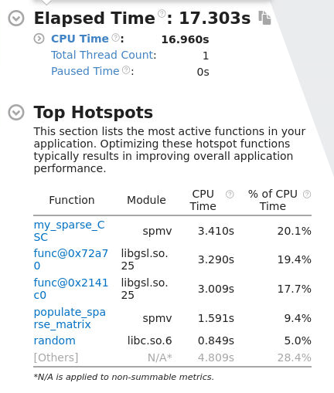

The function that consumes the most CPU time is my_sparse_CSC, followed by two functions from a library. Since the library functions are external, there is nothing we can optimize there.

For the populate_sparse_matrix function, its purpose is to populate the sparse matrix, and there is nothing significant to optimize in this routine.

Additionally, random, which is also from a library, cannot be optimized either.
Let’s focus on the my_sparse_CSC function.
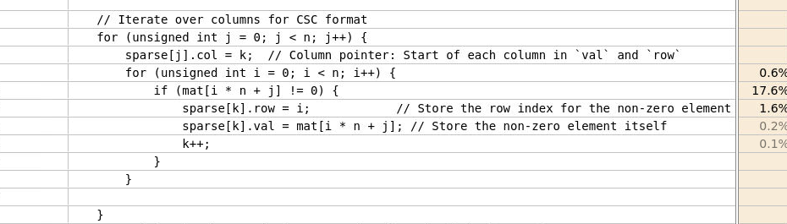

It seems to consume a lot of time due to the mat[i * n + j] operation, where we traverse the matrix column by column instead of row by row. In C, matrices are stored in row-major order (like a flattened table), so accessing elements row by row would typically be more efficient. Unfortunately, since this function is responsible for creating the CSC (Compressed Sparse Column) format matrix, column-wise traversal is required, and we cannot change this access pattern without altering the matrix format.

Memory Consumption

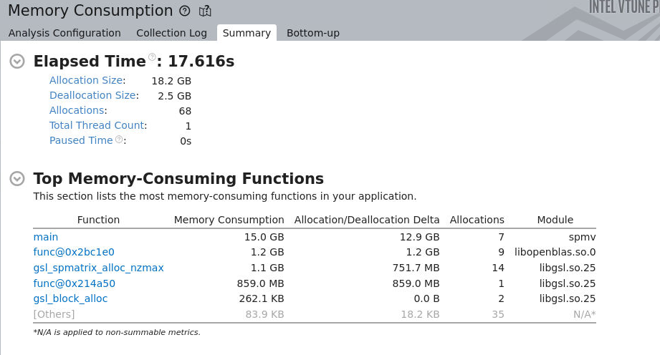

In the column "Allocation/Deallocation Delta," we can see that a significant amount of memory is not being deallocated. This indicates that we need to review the code to ensure proper deallocation of these data.

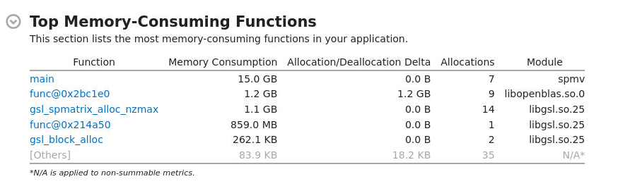

After improving the code, almost all the issues were resolved. The missing free() function calls were added, addressing most of the memory leaks. However, there is still one function, func@0x2bc1e0, which does not deallocate memory. Unfortunately, I don’t know which function this refers to since its name doesn’t refer directly to it.

Vectorization Analysis

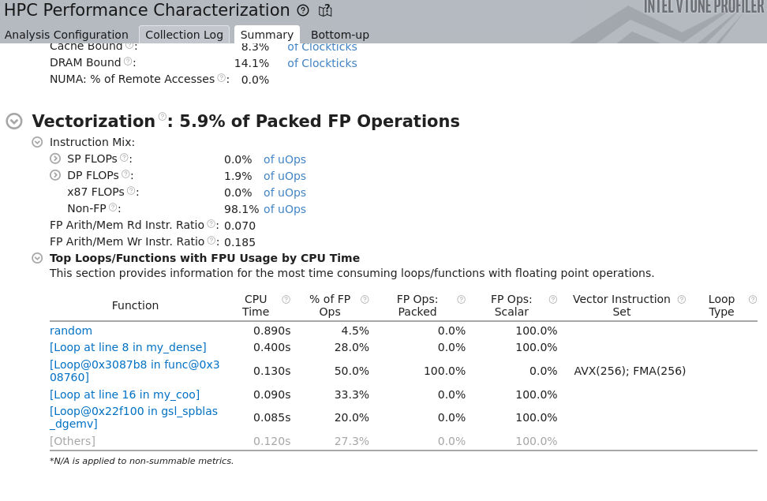
The vectorization efficiency is reported to be only 5.9%.
Despite using the compiler flags -g -c -Wall -Wextra -Ofast -ftree-vectorize, the low vectorization rate persists. The reason for this behavior is unclear and requires additional investigation.

